Solution of CNG vehicles refueling

Core products
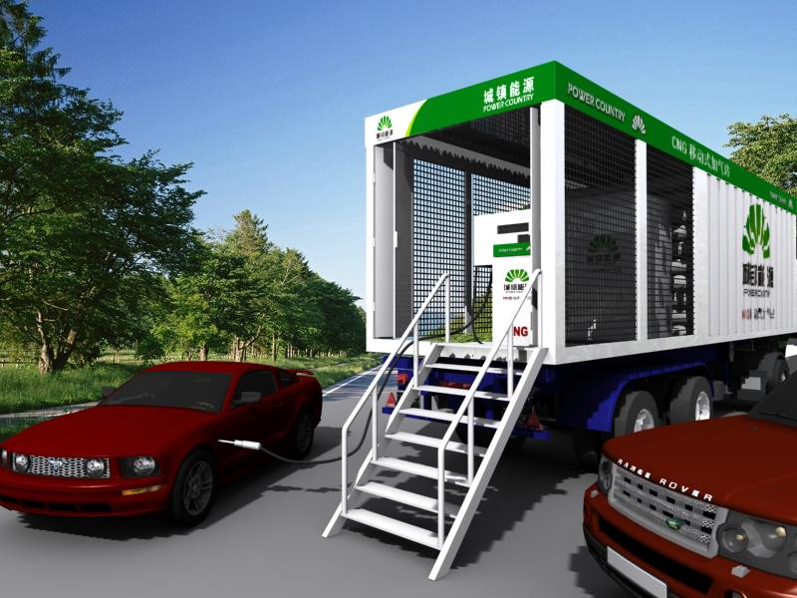
Picture 1 H-SONG CNG mobile station

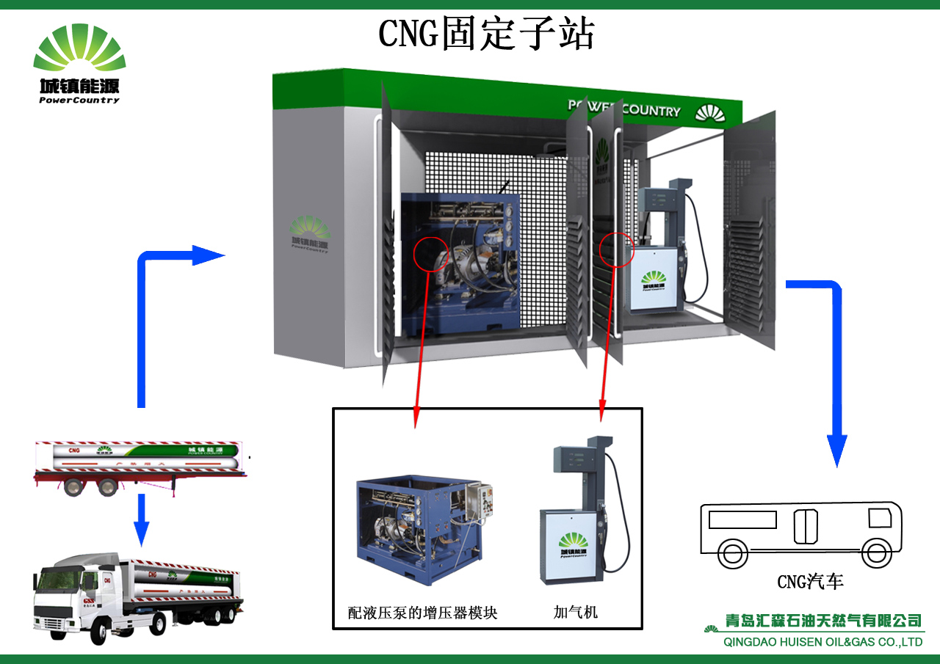
Picture 2 H-SONG CNG daughter system and CNG transportation
H-SONG Co. CNG station leads to a revolution of daughter station and mobile CNG station by virtue of its brand-new design notion, lower operating cost and perfect service system.
H-SONG mobile and daughter station consists of gas booster package, control cabinet, gas supply equipment, gas unloading parts, gas alarm, single-line double-hose dispenser, etc.
Characteristics:
Less investment: save around RMB1,000,000.00 compare to the compressor station
Low operating cost: 15kw main motor power, no need to add by electric power
High use rate: use rate of natural gas can reach 90% in CNG tube trailer
Short installation period: skid-mounted installation and commissioning, 48 hours enough
Fast refueling speed: above 700NM3/H
Advanced and reasonable design: fixed or removable type
Simple operation: can achieve unmanned operation

Compare
Configuration | Conventional CNG station | H-SONG mobile station
Pressurizing mode | Compressor | booster pressure system
Storage vessel | Yes | Yes(3000NM3)
Priority control panel | Yes | yes
Dispenser | 3 lines | Single line
CNG tube trailer | Common | Daughter station need
Gas unloading post | Yes | yes
Civil work | Complicated | Simple
Consumed power | 110-160kw | ≤15kw
Operating condition | Heavy vibration & noise | Light vibration & noise
Consumed energy of heat exchange | Higher | No
Remaining gas of tube trailer | ≥800Nm³ | Nearly 300 Nm³

In the conventional way, the pressure of tube trailer system reduces at any moment. In this case, compressor is required to pressurize and produce & vent heat. But during mechanical compression, low efficiency causes high energy loss. HUISEN mobile and daughter station system maintains high pressure status through hydraulic drived booster pressure system with small temperature difference change and low energy loss. Moreover, the effective power is much higher than the conventional way. H-SONG CNG station system can be designed a removable package with pressurizing system and dispenser. It can be installed in the any area without gas source.
picture 4: working principle and configuration

QINGDAO H-SONG ENERGY EQUIPMENT Co.，LTD
http://www.huisenpower.com
http://www.china-fln.com
e-mail:gss1956@126.com
tel/fax:0532-83882367qingdao

